New House Captains

By [Vikrant Sabharwal](mailto:22sabharwalv@brooklinek12.org)

BISB has elected new house captains!

There are four houses at BISB: Adams, Franklin, Jefferson, and Harvard. Students throughout the school are assigned to one of the houses so each house spans from students Year 1 through Year 13. Miss Reilly thinks developing BISB’s current house system is an important step to unify the school, across the primary, middle, and high school levels, and build heightened school spirit.

This year’s House Captains and vice captains are as follows:

* Adams: Faisal Khreis (Captain-Year 13), Tara Ossiani (Vice Captain-Year 12)
* Franklin: Ujjaini Saha (Captain-Year 13), Armaan Goli (Vice Captain-Year 12)
* Harvard: Michael Sherris (Captain-Year 13), Rohini Pillay (Vice Captain-Year 12)
* Jefferson: [Victor Delacroix](mailto:22delacroixv@brooklinek12.org) (Captain-Year 13) and Vikrant Sabharwal (Captain-Year 13)

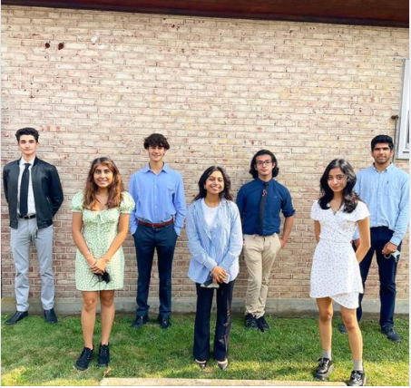

Photo of BISB’s new house captains

Faisal Khreis expressed his appreciation at the new position; “I am absolutely honored to be a house captain,” he said. “It allows me to take into account feedback from students and teachers and really make a difference in the school. I hope to continue to increase the level of house spirit at BISB.”

The Houses all have their own colors. Adams is yellow; Franklin is red; Harvard is blue; and Jefferson is green.

Houses will compete with each other on the basis of house points. House points are awarded for good behavior, hard work, kindness, winning competitions, and more. Prizes awarded to students who contribute the most, second most, and third most points to their house. This motivates students to have a positive attitude in school both in and out of the classroom.

Each half-term, the house with the most points will be the winner. After the first half-term, Jefferson is in the lead with the most house points, at 206.1. Harvard, Franklin, and Adams follow behind in that order.

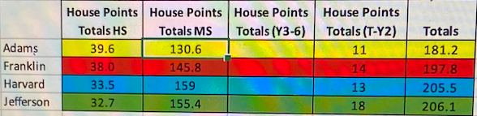

On Friday, October 8th, each house hosted their first assembly of the year. Due to COVID-19 restrictions, there had to be separate assemblies for the primary and middle/high school. Both assemblies consisted of a quiz for which students competed for house points. They also announced their plans for spirit week.

Khreis greatly enjoyed his house’s assembly. “It was great to meet and get to know the members in Adams,” he said. “It was quite an enjoyable experience to bring together students from a wide range of year groups, from Year 7’s to 13’s in the middle/high school assembly and Year 1’s to Year 6’s and the primary school assembly.”

Students at BISB are very excited about the house system and are excited to compete against each other. The House System is uniquely able to unify the entire school as it is one of the few things that a Year 13 shares with a Year 1 within BISB. By bringing strong student engagement and leadership, the House system has the potential to fundamentally shape school spirit at BISB.

Spirit week will take place on the week of Halloween, the week of October 25th. Each House is in charge of the spirit theme for one day in the week.

* Monday: Adams’ theme is to dress up as your favorite hero, which could be from a book or movie. Their activity for that day will be for students to write a short story about their super hero.
* Tuesday: Franklin’s theme is to dress up as a detective, real or fictional. Their activity will entail a whole-school scavenger hunt with house points for finding each object. J
* Wednesday: Jefferson will have students dress up representing their home country of flag colors. To go along with this, they will have road games, including darts, cup throw, bag racing, and more, where houses will compete against each other.
* Thursday will be Harvard’s day. They will have a MET Gala dress up, where students express their fashion in unique and fancy ways. There will be awards for the best dressed, most creative, and most colorful.
* Friday: Time to dress-up for Halloween! Students can dress up anything, apart from scary masks or other gory items. There will be competitions in the form of house-themed pumpkin decorating. Students will bring in their own pumpkin and decorate them, and each class will vote for their favorite pumpkins.